Problem 1 – Parametric Method: Discriminant Analysis

Background Information:

Discriminant Analysis is a technique to find the projection that best separates the data in a least squares sense.

Fisher Linear Discriminant is the special case when projecting the data from d dimensions onto a line.

Choices of the separation plane, w

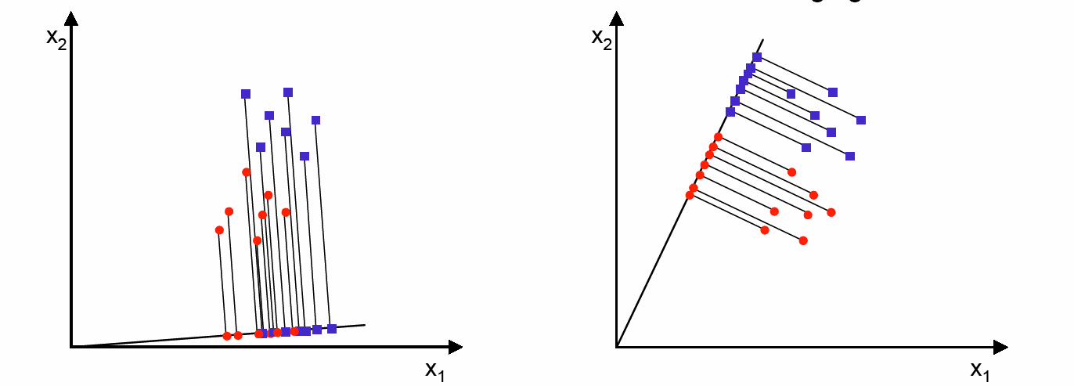

Figure 1. Projection of same set of two-classes samples onto two different lines in different directions. Left: classes missed Right: Better separation

Given the sample mean in the d-dimensional space,
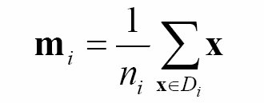
The sample mean of the projected points is
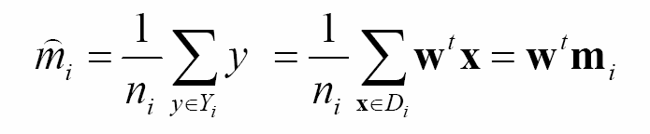
The distance between projected means is
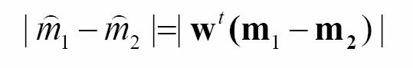
and we want this quantity as large as possible for because it is the separation between the two projected sets.

Instead of forming sample variances, define scatter for the projected samples,
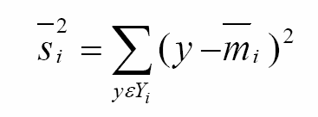
It measures the within class scatter, indicating how packed the data is. So for clearer separation, we want this quantity to be as small as possible.

Define 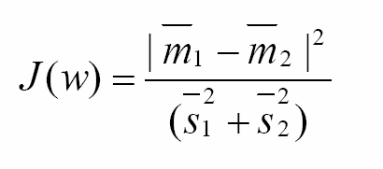and maximize it to achieve the previous two requirements. To express 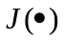as an explicit function of w, S_{i} and S_{w}.

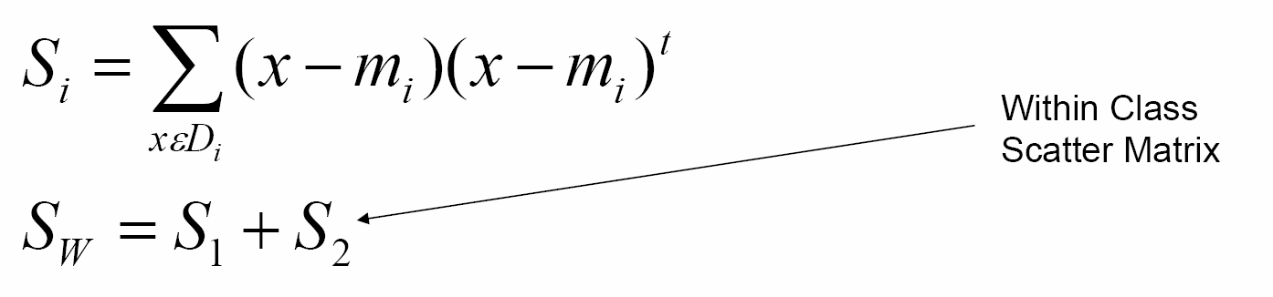
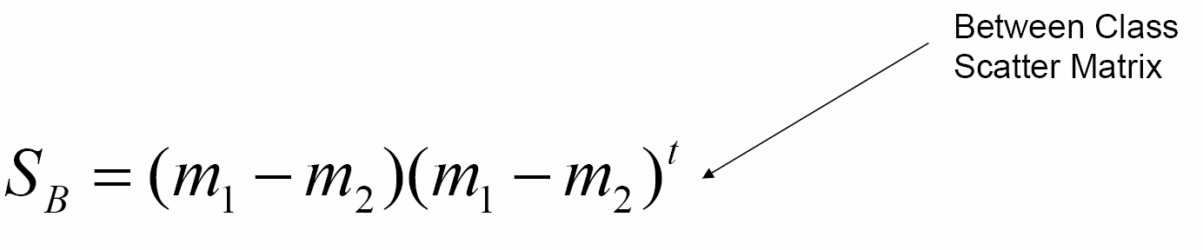

can be written as

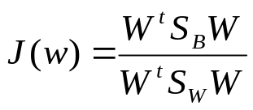

If S_{w} is non-singular, this problem turns into a conventional eiganvalue problem,

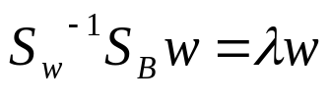

In our case, since S_{b} w is always in the direction of m1-m2, the solution can be obtained immediately, hence the solution for the w that optimizes

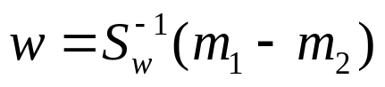

Experiments and Results

The data we use is N(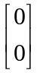,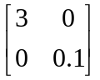) and N(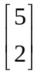,). The data from two classes is plotted in the figure below. In this particular case, the vertical axis obviously forms a better separation for both classes then the horizontal axis. However, if only the numerator of is optimized, the optimization of the denominator is neglected with S_{w} set to the identity matrix, then the horizontal axis will be chosen over the vertical axis as a better separation because it has a larger between class distance, |m₁-m₂|. It ignores the variances of the within class scatter matrices.

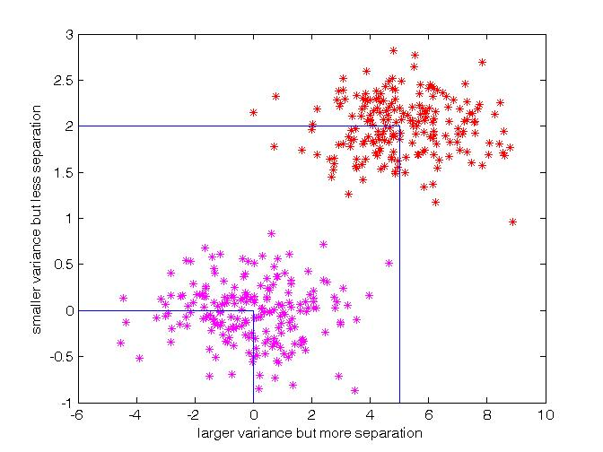
Figure 2. Two classes of data to illustrate the importance of optimizing Sw

To illustrate this, the same set of data is projected onto a line in the optimal direction computed by Fisher Linear Discriminant and it is denoted by W_{opt} and a line with only numerator of maximized, denoted by W_{sw=I}. The plot is shown in Figure 3. The solid line has the projected data with maximun |m₁-m₂|, but it does not take the variance of the within class scatters into account. The dotted line gives the optimal solution that takes both |m₁-m₂| and S₁, S₂ into account.
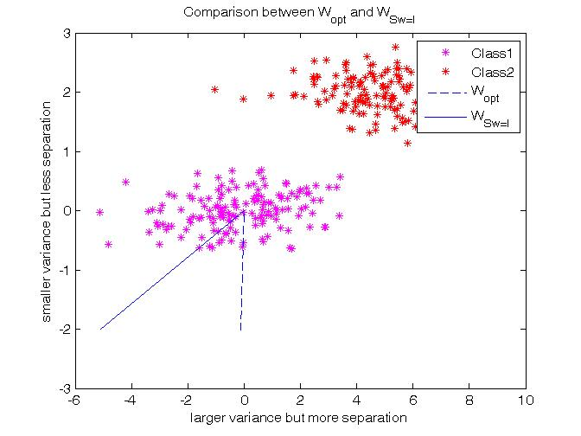
Figure 3. Results for optimizing and the numerator of only

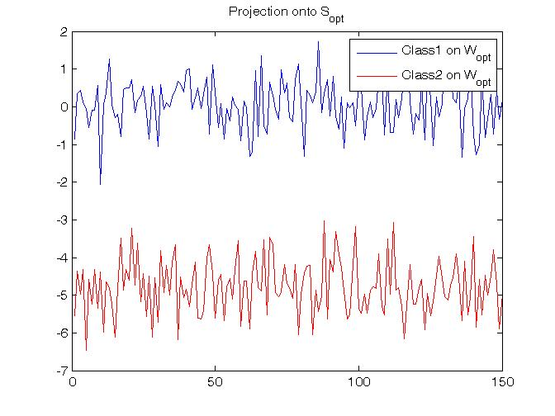
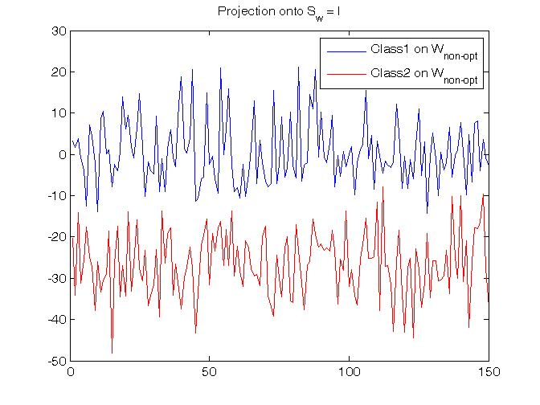
Figure 4. The projection onto W_{opt} is more separable then W with S_{w}=I
The projections of the data on two different lines are shown in Figure 4. It clearly shows that the result using Fisher Linear Discriminant is better separated because of the smaller within class variances.
The experiments is data dependent because if N(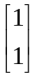,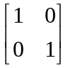) and N(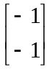,) is used, there will not be obvious difference between the results for W_{opt} and _{WSw=I} because the within class scatter variances are the same in all direction, as a result optimizing the denominator of or not give the same results.

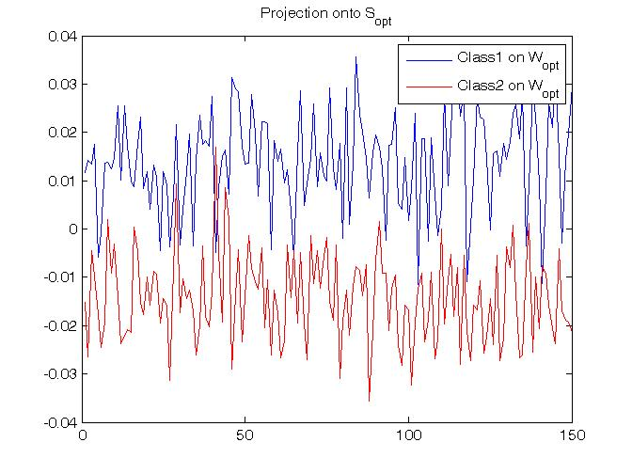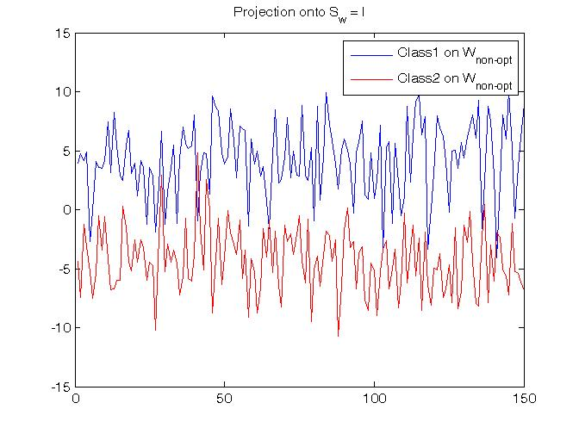
Figure 5: With N(,) and N(,) , both projections are not very separable
Problem 2 - Neural Network:

Background Information

A basic artificial neural network architecture consists of several layers of artificial neurons connected together. The neurons that receives information from outside the network are considered to be in the input layer. If a neuron contains the network's predictions or classifications, it is in the output layer. Those between them are in the hidden layer. The input neurons are scaled between 0 and 1 or -1 to 1. Then there is a transfer function, it can ne a log function, sigmoid function, or a hyperbolic tangent function.

As values are sent from one layer to the next, a weight is assigned to each interconnecting line and is multiplied by the values. Each neuron on the hidden layer sums all inputs, and the combined input is modified by the transfer function.

The output value of the transfer function is generally passed directly to all neurons in the next layer, again with a weight assigned to each value. Values of the interconnecting weights predetermine the neural network's computation reaction to any arbitrary input pattern. As information is passed forward from the inputs toward the outputs, interconnecting weights are adjusted by a back-propagation algorithm during the learning phase so that known outputs will best match predicted outputs.

In order to adjust the weights based on the training patterns and matching the known outputs to the predicted outputs, each epoch changes the weight by an amount proportional to the different between the desired output and actual output.

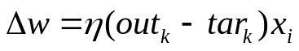

Where out is the target output, out is the actual output, and is the learning rate.
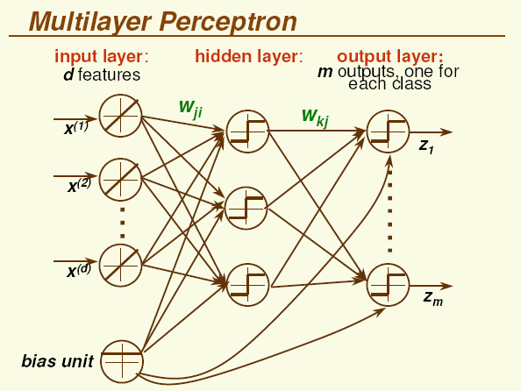
Figure 5. Neural Netowrk

Neural Network:

1D samples with distribution N(1,2) and N(-1,2) are used in out experiments. Half of the samples are used as the training data and the remaining half is used for testing. To show the performance of the classifiers, the error training for different number of nodes is plotted in the following figure. N1 denotes the number of nodes in the first layer, N2 is the number of nodes in the hidden layer, and N3 is the number of nodes in the last layer.

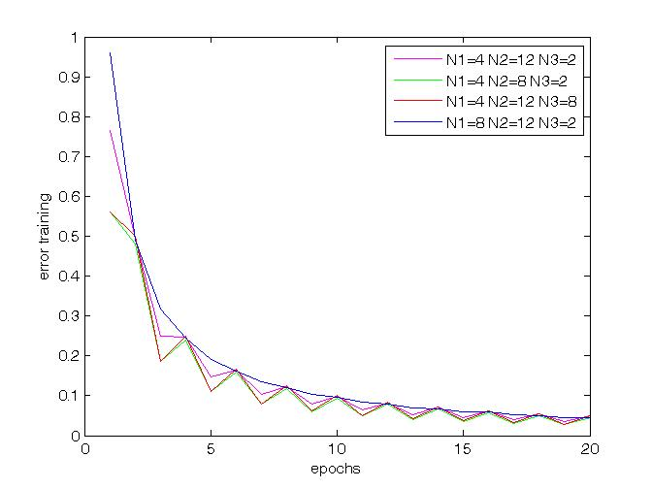
Figure 6. Error training as a function of number of epochs
Support Vector Machine:

Background Information

Support vector machines map a given set of binary labeled training data to a high-dimensional feature space and separate the two classes of data with a maximum margin hyperplane.

This problem is reformulated as one of maximizing
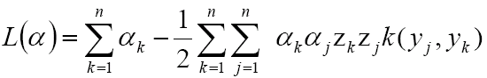
Subject to the constraints
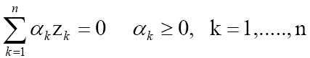
Given the training data.
Where the kernel function is defined by
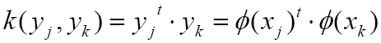

Implantation can be done using quadratic programming.

Experiments and Results

The set of data used is N(1,2) for class 1 and N(-1,2) for class 2. The number of support vectors and number of Misclassification are plotted in Figure 7.

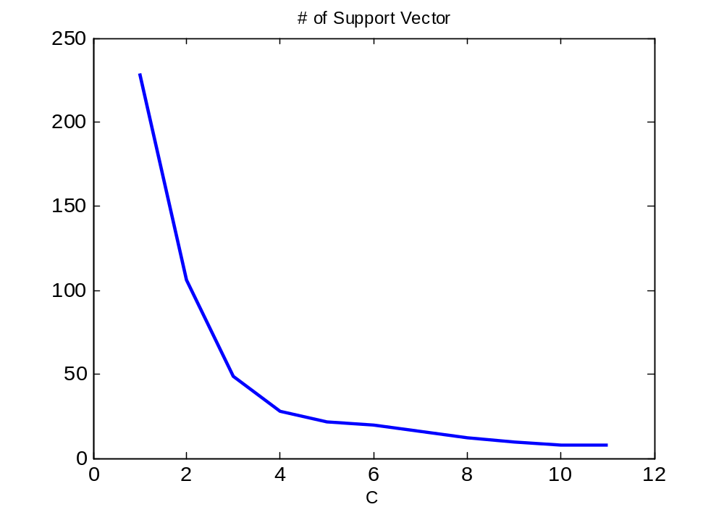

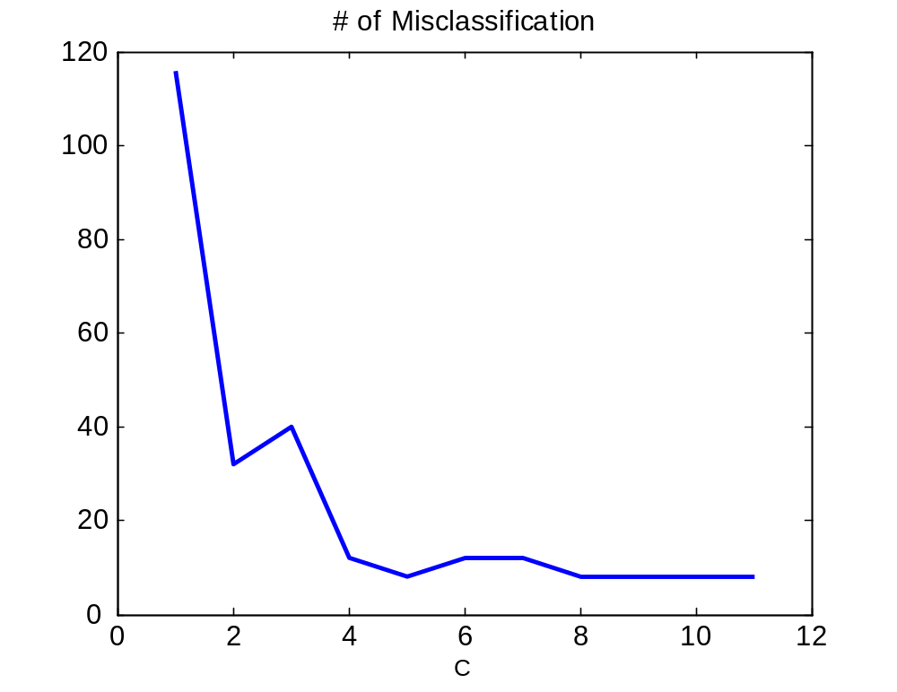
Figure 7: The number of support vectors and number of Misclassification.
Problem 3

Classification using K-Nearest Neighbor and Nearest Neighbor

- K-Nearest Neighbor classifies an unknown vector by assigning it the label most frequently represented among the k nearest samples and use a voting scheme. An example is shown in the figure below, the unknown data point is classified into either class 1 or class 2. Using the KNN method, with K=5, the nearest 5 neighbors are used for the voting scheme. The metric used is the Euclidean distance. Since there are more samples from class 1 then the number of samples from class 2, this unknown data point is classified into class 1.

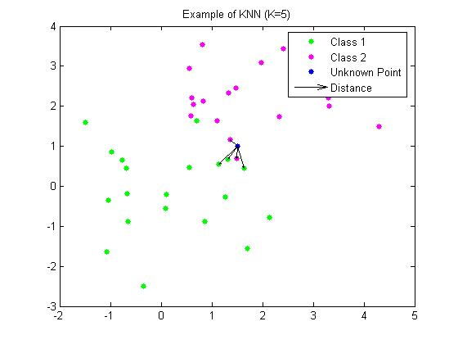
Figure 8: The unknown sample point is classified into Class 1.

KNN has k fixed but its volume is a function of the data. It centers each cell (region) at x0 and let it grow until it captures k samples.

If the density of samples is high near x, the cell will be small, and if the density is low, the cell will be large.

The method Nearest Neighbor is a special case of K-Nearest Neighbor when k = 1.
An unknown data will be classified to the same class as its nearest neighbor is in.

Experiments and Results

1D samples with distribution N(1,2) and N(-1,2) are used to train and test the algorithms. With total number of sample points = 150 and number of neighbors = 5 for kNN, the probabilities of the sample in class 1 and class 2 are plotted in the following figures.

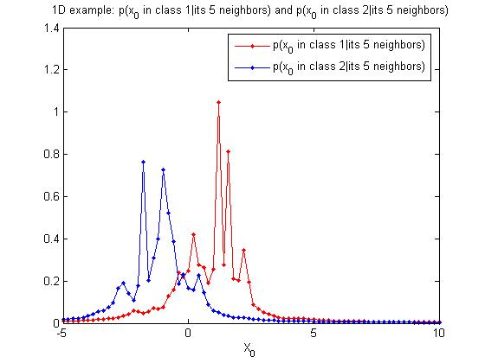
Figure 9: kNN with k = 5

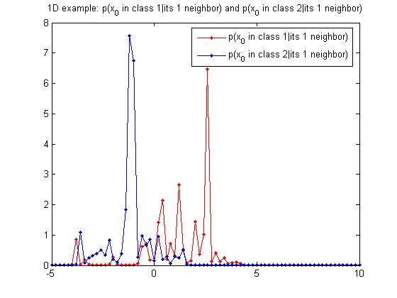
Figure 10: NN

Classification Rules:
For two classes, we estimate the probability 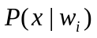, i=1, 2, as 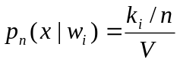
Then we compare 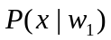 and 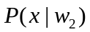and choose the larger one as the class of sample x.

Error rate of kNN and NN:

Comparing k-NN to NN, k-NN has the advantage in that it is more robust to outliers (noise) in the training data as not a single data point is relied upon but a neighborhood of K points.

The error rate of classification using different values of K is shown in Table 1. The experiment shows that the error rate if higher when using NN (K = 1), and the error rate decreases as the number of neighbors considered increases.

However there is a drawback for using a larger K, it has to find more nearest neighbors, and it can be slow for a large training set.

Optimal k for normal distributions, it depends on the dimension of the data

 | K=1 | K=3 | K=5 | K=7
Error Rate | 0.35 | 0.29 | 0.25 | 0.24

Table 1: Error rate for different values of K

Experiments with 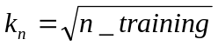 are also done to shown the error rate of different size of the training set.

 | K=  sqrt(1000) | K=  sqrt(10000) | K= sqrt(100000) | K= sqrt(1000000)
Error Rate | 0.2032 | 0.223 | 0.2388 | 0.2338

Table 2: Error rate for different values of K

Classification using Parzen Windows

Parzen Windows classifies an unknown vector by assigning it the label most frequently represented among the nearest samples within a region 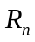 which is a d-dimensional hypercube of fixed size using a voting scheme. The length of an edge of the hypercube is denoted by 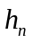is, and the volume of it is denoted by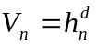.

- An example is shown in the figure below, the unknown data point is classified into either class 1 or class 2.

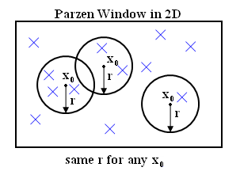

Figure11: Parzen Windows has a fixed volume but number of data point is a function of the data. Kn can be 3 (left), 2 (middle), or 1(right).

If the density of samples is high near x, the cell will capture more samples (larger k), and if the density is low, the cell will capture less samples (smaller k).

Density Estimation using Parzen Windows

A window function 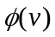is needed for density estimation using Parzen Windows. Examples of windows include unit function, Gaussian function, Epanechnikov function, and Traingle function. The estimated density is given as:

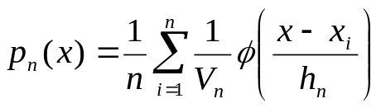

In our experiment, the density is expressed as:

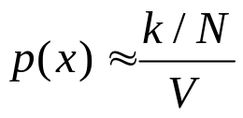

Where x is the sample inside some region R, k is the number of samples inside R, n is the total number of samples inside R, and V is the volume of R

Effect of Window Size h

By choosing h, we are guessing the region where density is approximately constant. If h is too small, we superimpose n sharp pulses centered at the data, so the result will be noisy and not smooth. On the other hand, if h is too large, the result will be over-smoothed and lack of details. As h increases, the ‘smoothing’ effect increases as well.

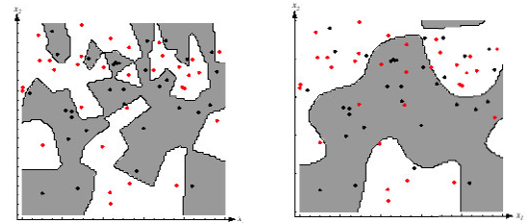

Figure 12.
Left: For small h, classification on training data is perfect. However, decision boundaries are complex.
Right: For large h, classification on training data is not perfect. However, decision boundaries are simpler.

Experiments and Results

The set of samples used are N(1, 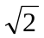) and N(-1, ) . Different window size and different number of samples are varied to show their effect on the estimation.

The results for classification using Parzen Windows is show in table 3 and the results of the density estimation of the training samples are shown in the following figures.

P(e) | N = 1000 | N = 10000
h1 = 0.1 | 0.3530 | 0.2510
h1 = 1 | 0.2360 | 0.2280
h1 = 5 | 0.2100 | 0.2350
h1 = 10 | 0.2100 | 0.2350

Table 3. Probability of error using different window size and number of samples

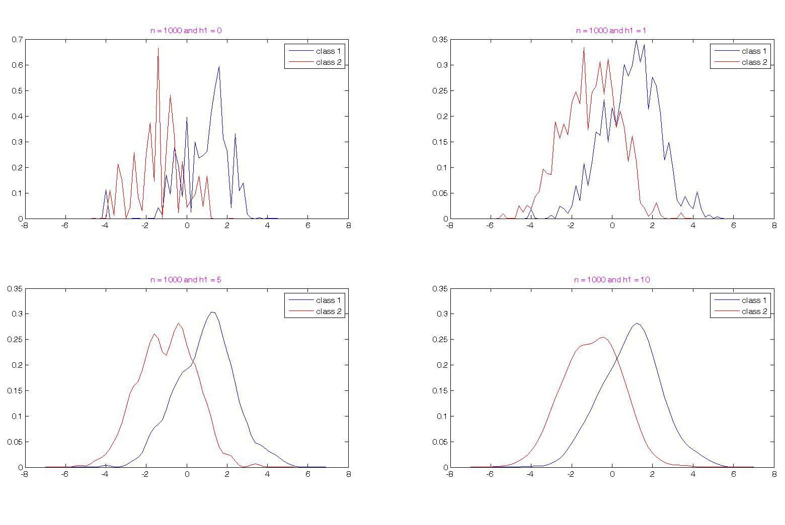
Figure 13: Number of samples used = 1000 and window size = 0.1,1 , 5, 10
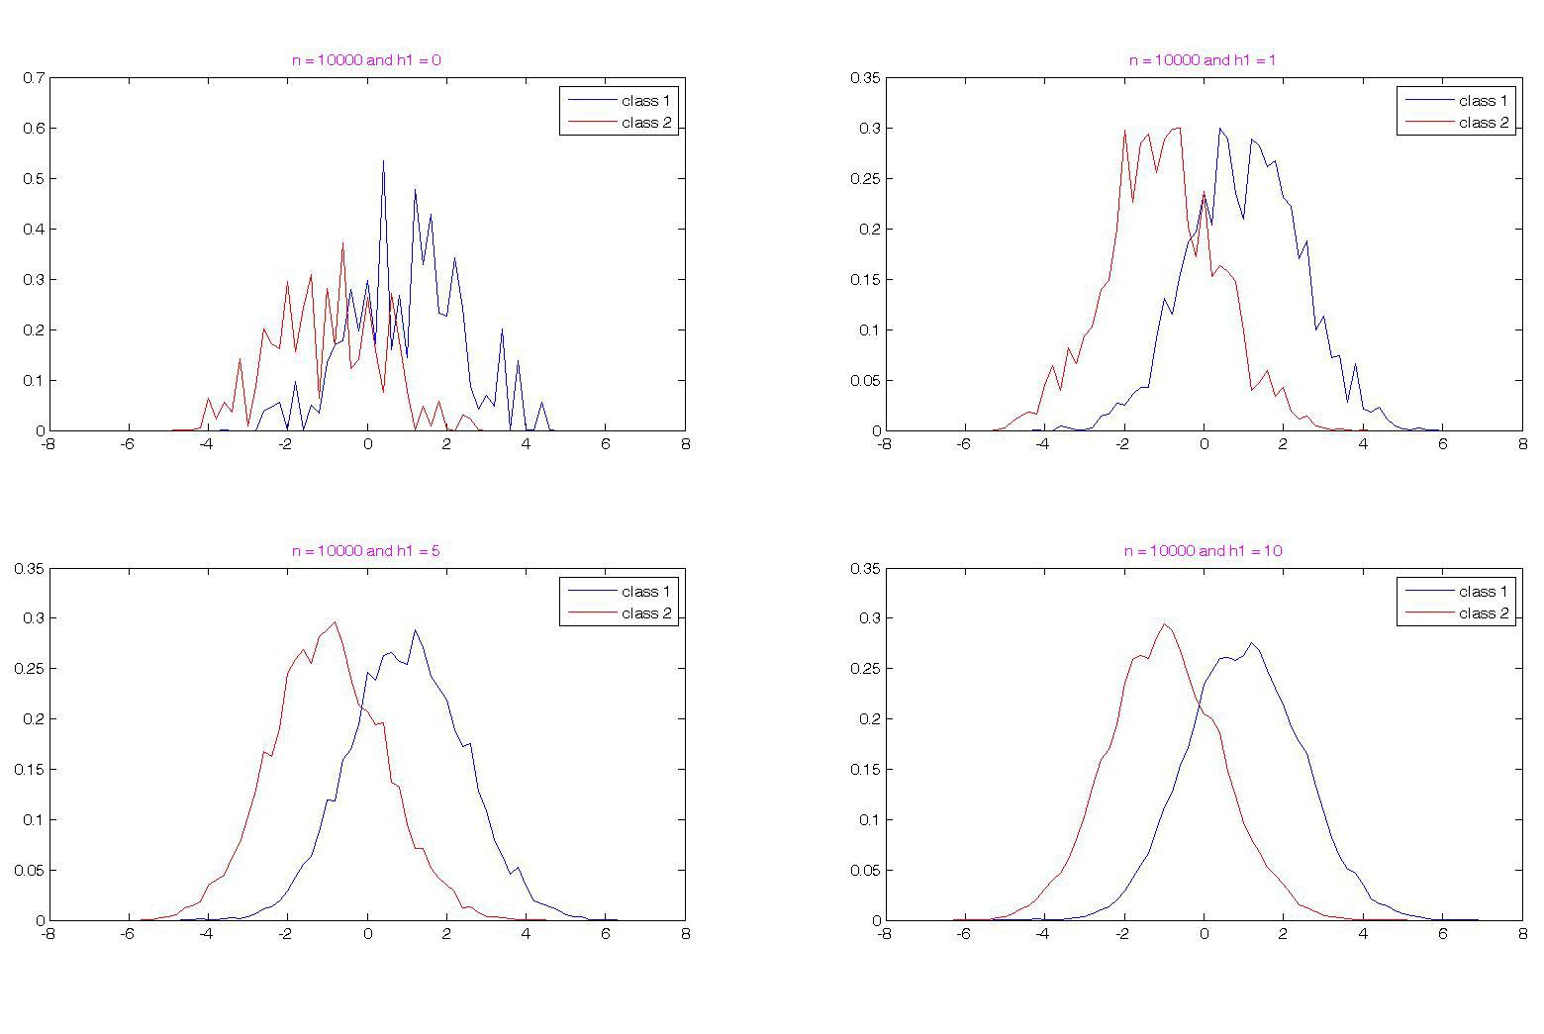 Figure 14: Number of samples used = 10000 and window size = 0.1,1 , 5, 10

The results show that if the window size is too large, a lot of details will be missed. If the window size is too small, the estimation will suffer from too much statistical variability.

For data that is clustered less densely, hence data vectors are more spread out. Small kernels for Parzen windows and small k values for kNN tend to result in overfitting since it is likely that points from a different class are close to the examined data vector.
Problem 1

% Nearest Neighbor
% sample data
n = 100;
train_data = n/2;
test_data = n/2;

% Data set 1:
mean_x1 = 1;
var_x1 = 2;
x1 = mean_x1 + sqrt(var_x1)*randn(1,n);
x1_train = x1(1:train_data);
x1_test = x1(train_data+1:end);

% Data set 2:
mean_x2 = -1;
var_x2 = 2;
x2 = mean_x2 + sqrt(var_x2)*randn(1,n);
x2_train = x2(1:train_data);
x2_test = x2(train_data+1:end);

% function of kn (KNN)
kn = ceil(sqrt(train_data));
% function of kn (NN)
%kn = 1;

x = -5:0.2:10;
L_x = length(x);
p1_nn = zeros(1,L_x);
p2_nn = zeros(1,L_x);

for i = 1:L_x
index_sort1 = sort(abs(x1_train - x(i)));
V1 = 2 * index_sort1(kn);
index_sort2 = sort(abs(x2_train - x(i)));
V2 = 2 * index_sort2(kn);
if (V1 > 0)
p1_nn(i) = kn/train_data/V1;
end
if(V2 > 0)
p2_nn(i) = kn/train_data/V2;
end
if (p1_nn(i)>10)
p1_nn(i)=0;
end
if (p2_nn(i)>10)
p2_nn(i)=0;
end
end

figure
plot(x,p1_nn,'r.-',x,p2_nn,'b.-')

% Classification

error_nn_total = 0;
error1 = 0;
error2 = 0;

for i = 1:test_data
j1_nn = find(abs(x-x1_test(i)) <=0.1);

if (p1_nn(j1_nn) < p2_nn(j1_nn))
error1 = error1 +1;
end

j2_nn = find (abs(x-x2_test(i))<=0.1);

if(p2_nn(j2_nn) < p1_nn(j2_nn))
error2 = error2 +1;
end
end
error_nn_total = (error1 + error2)/2/test_data

Problem 3

n = 1000;
train_data = n/2;
test_data = n/2;

% Data set 1: x1 with distribution N(a,b) (mean=a, var=b)
mean_x1 = 1;
var_x1 = 2;
x1 = mean_x1 + sqrt(var_x1)*randn(1,n);
x1_train = x1(1:train_data);
x1_test = x1(train_data+1:end);

% Data set 2: x2 with distribution N(a,b) (mean=a, var=b)
mean_x2 = -1;
var_x2 = 2;
x2 = mean_x2 + sqrt(var_x2)*randn(1,n);
x2_train = x2(1:train_data);
x2_test = x2(train_data+1:end);

% 1st estimation by Parzen window

d = 1; % dimention
x = -7:0.2:7;
L_x = length(x);
%setting h1
error_total = zeros(1,3);
error_parzen_prob = zeros(1,3);
hh1 = [0.1 1 5 10];
for kk=1:length(hh1)
h1 = hh1(kk);
hn = h1/sqrt(train_data);
Vn = hn^d;

Q1 = zeros(1,train_data);
prob1_train = zeros(1,L_x);

Q2 = zeros(1,train_data);
prob2_train = zeros(1,L_x);

for i = 1:L_x
for j = 1:train_data
Q1(j) = 1/(sqrt(2*pi))*exp(-(x(i) - x1_train(j))^2/(2*hn^2));
Q2(j) = 1/(sqrt(2*pi))*exp(-(x(i) - x2_train(j))^2/(2*hn^2));
prob1_train(i) = prob1_train(i) + 1/train_data*1/Vn*Q1(j);
prob2_train(i) = prob2_train(i) + 1/train_data*1/Vn*Q2(j);
end
end
subplot(2,2,kk);
plot(x,prob1_train,'b-', x,prob2_train,'r-')
legend('class 1','class 2');
title(['n = ',int2str(n),' and h1 = ',int2str(h1)],'Color','m');

% 2nd step classification and errors by Parzen window method
error1 = 0;
error2 = 0;
for i = 1:test_data
parzen = find(abs(x-x1_test(i)) <= 0.1);
if (prob1_train(parzen) < prob2_train(parzen))
error1 = error1 + 1;
end
parzen2 = find(abs(x-x2_test(i)) <= 0.1);
if(prob2_train(parzen2) < prob1_train(parzen2))
error2 = error2 + 1;
end
end

error_total(kk) = error1 + error2
error_parzen_prob(kk) = error_total(kk)/(2*test_data)

end

Problem 2a

close all;
clear all;
%rand('state',100);
% the neurons have a sigmoid function activation
% data length

for kk=1:4
N123 = [3 10 3 3 ; 10 4 4 4 ; 2 2 10 2];
N1=N123(1,kk);
N2=N123(2,kk);
N3=N123(3,kk);

% length training set
% iter = epochs
iter = 20;
iter_test = 20;
Target = zeros(1,N3);

% initialize weights

W_hid_in = rand(1,N1);
W_hid_out = rand(1,N2);
error_epoch = zeros(1,iter);
error_epoch_test = zeros(1,iter_test);
Mean1 = 1;
Mean2 = -1;
std1 = 2;
std2 = 2;
data_class1 = Mean1 + std1*randn(1,N1);
data_class2 = Mean2 + std2*randn(1,N1);
for k=1:iter
if (mod(k,2)==0)
training_data = data_class1;
else
training_data = data_class2;
epoch=k,
end
for i=1:N1
sig_output(i) = training_data(i);
end
% training the neural network step
% outputs
for n=1:N3
in_last(n)=0;
for j=1:N2
input_hid(j)=0;
for i=1:N1
input_hid(j) = input_hid(j)+W_hid_in(i)*sig_output(i);
end

W_old_hidden(:,j) = W_hid_in';
sig_output_hid(j) = (1)/(1+exp(-input_hid(j)));
in_last(n) = sig_output_hid(j)*W_hid_out(j)+in_last(n);
end
out(n) = (1)/(1+exp(-in_last(n)));

W_old_output(:,n) = W_hid_out';

end

lear_rate = 0.25;

% backpropagation step

% calculate errors of output neurons
for i=1:N3
delta(i) = out(i)*(1-out(i))*(Target(i)-out(i));
end
% Change output layer weights
for i=1:N2
for j=1:N3
W_new_output(i,j) = W_old_output(i,j)+lear_rate*delta(j)*sig_output_hid(i);
end
end
% back-propagate
for i=1:N2
ssuumm=0;
for j=1:N3
ssuumm = delta(j)*W_new_output(i,j)+ssuumm;
end
delta_hid(i) = sig_output_hid(i)*(1-sig_output_hid(i))*ssuumm;
end

% change hidden layer weights
for i=1:N1
for j=1:N2
W_new_hidden(i,j) = W_old_hidden(i,j)+lear_rate*delta_hid(j)*training_data(i);
end
end

W_old_output = W_new_output;
W_old_hidden = W_new_hidden;

% forward pass with the new weights
for i=1:N1
sig_output(i) = training_data(i);
end
% outputs
for n=1:N3
in_last(n) = 0;
W_hid_out = W_new_output(:,n)';
for j=1:N2
input_hid(j) = 0;
W_hid_in = W_new_hidden(:,j)';

for i=1:N1
input_hid(j) = input_hid(j)+W_hid_in(i)*sig_output(i);
end
sig_output_hid(j) = (1)/(1+exp(-input_hid(j)));
in_last(n) = sig_output_hid(j)*W_hid_out(j)+in_last(n);
end
output(n,k) = (1)/(1+exp(-in_last(n)));
error(k) = abs(Target(n)-output(n,k));
end
error_epoch(k) = (error_epoch(k)+error(k))/k;
end
x=1:iter;

hold on;
if kk==1 plot(x,error_epoch,'m'); end
if kk==2 plot(x,error_epoch,'g'); end
if kk==3 plot(x,error_epoch,'r'); end
if kk==4 plot(x,error_epoch,'b'); end

xlabel('epochs');
ylabel('error training');

y=zeros(1,iter_test);
%% Testing...
for k=1:iter_test
data_class1 = Mean1 + std1*randn(1,N1);
data_class2 = Mean2 + std2*randn(1,N1);
% Generating the test data
p=randperm(2);
if (p(1)==1)
training_data = data_class1;
else
training_data = data_class1;
end
epoch=k,
for i=1:N1
sig_output(i) = training_data(i);
end
% outputs
for n=1:N3
in_last(n) = 0;
for j=1:N2
input_hid(j) = 0;
for i=1:N1
input_hid(j) = input_hid(j)+W_hid_in(i)*sig_output(i);
end
sig_output_hid(j) = (1)/(1+exp(-input_hid(j)));
in_last(n) = sig_output_hid(j)*W_hid_out(j)+in_last(n);
end
outpu_test(n,k) = (1)/(1+exp(-in_last(n)));
error_test(k) = abs(Target(n)-outpu_test(n,k));
end
error_epoch_test(k) = (error_epoch_test(k)+error_test(k))/k;
y(k)=(y(k)+1)/k
end
x=1:iter_test;
%hold on; plot(x,y,'b'); hold on;
%hold on; plot(x,error_epoch_test,'c'); hold off;
W_hid_in,
W_hid_out,

end

Problem 2b

clear; % clear variables from memory
close all;
nsample = 100;
X = zeros(nsample,1);
Y = zeros(nsample,1);
Mean1 = 0;
Mean2 = -1;
std1 = 2;
std2 = 2;
data_class1 = Mean1 + std1*randn(1,nsample/2);
data_class2 = Mean2 + std2*randn(1,nsample/2);
X(1:nsample/2) = data_class1;
X(nsample/2+1:nsample) = data_class2;
X = sort(X);
plot(data_class1,'ko');hold on;
plot(data_class2,'g+');
p = randperm(nsample);
Y(p(1:nsample/2)) = -1;
Y(p(nsample/2+1:nsample)) = 1;

% the trade-off weights we want to investigate , 2000, 5000, 10000, 100000
C = [0.1, 1, 5, 10, 20, 50, 100, 200, 500, 1000];

Margin = []; % margin; initialized as null
nSV = []; % number of support vector;
nMis = []; % number of misclassification;
Err = []; % training errors;
X,Y,
for n = 1 : max(size(C)),
% construct Hessian matrix; Hessian matrix is the Q matrix in our slides; also called Kernel matrix
H = zeros(nsample, nsample); % initialize H; set H to a nsample * nsample zero matrix
for i = 1 : nsample,
for j = 1 : nsample,
H(i,j) = X(i)*X(j)*Y(i)*Y(j); % !!! please write your answer here !!!
end
end
H = H+1e-10*eye(size(H)); % add 1e-10 to the main diagonal of H; a trick to make H stable
F = -ones(nsample,1); % F' * Alpha corresponds to sigma_i(Alpha_i) in object function
% set up equality constraints
A = Y'; % corresponds to sigma_i(Alpha_i * Y_i) = 0
b = 0;

% set up upper and lower bounds for alpha: LB <= Alpha <= UB
UB = zeros(nsample,1);
LB = C(n)*ones(nsample,1);

% starting point of alpha
Alpha0 = zeros(nsample, 1);

% optimizing alpha with quadratic programming

[Alpha] = quadprog(H, F, [], [], A, b, LB, UB, Alpha0),

% Alpha = qp(H, F, A, b, LB, UB, Alpha0, 1);

% tolerance for support vector detection; we will ignore the alphas less than tol
tol = 0.0001;

% calculate weight
w = 0;
for i = 1 : nsample,
w = w + Alpha(i) * Y(i) * X(i);
end

% calculate bias
bias = 0;
b1 = 0;
b2 = 0;
for i = 1 : nsample,
if (Alpha(i) > tol & Alpha(i) < C(n) - tol),
b1 = b1 + X(i) * w - Y(i);
b2 = b2 - 1;
end
end

if b2 ~= 0,
bias = b1 / b2;
else % unlikely
b1 = 0;
for i = 1 : nsample,
if Alpha(i) < tol,
b1 = b1 + X(i) * w - Y(i);
b2 = b2 - 1;
end
end

if b2 ~= 0,
bias = b1 / b2;
else % even unlikelier
b1 = 0;
for i = 1 : nsample,
b1 = b1 + X(i) * w - Y(i);
b2 = b2 - 1;
end
if b2 ~= 0,
bias = b1 / b2;
end
end
end

% margin = 2 / ||w||
Margin = [Margin, 2 / abs(w)]; % the operation A = [A, v] appends v to matrix A

% number of support vectors
nSV = [nSV, size(find(Alpha > tol), 1)];

% calculate # of misclassification and training error
m = 0;
e = 0;
for i = 1 : nsample,
predict = w * X(i) + bias; % Y = w * X + b
if predict >= 0 & Y(i) < 0,
m = m + 1;
end
if predict < 0 & Y(i) >= 0,
m = m + 1;
end
if Alpha(i) > tol, % consider support vectors only; why?
e = e + 1 - predict * Y(i);
end
end
nMis = [nMis, m],
Err = [Err, e],
end

% plot C_margin, C_trainingerror, C_misclassification, C_nsupportvector
% please use your code to make better plots instead of ours

Z = zeros(size(C));
for i = 1 : size(C, 2)
Z(i) = i;
end

figure
plot(Z, Margin);
title('Margin');
xlabel('C(i)');

figure
plot(Z, Err);
title('Training Error');
xlabel('C(i)');

figure
plot(Z, nMis);
title('# of Misclassification');
xlabel('C(i)');

figure
plot(Z, nSV);
title('# of Support Vector');
xlabel('C(i)');

